Persia/Greek Notes
Persia
- By ____________________ BCE, _______________________ had established a massive empire from the Middle East to _____________________
- Tolerant of ________________________
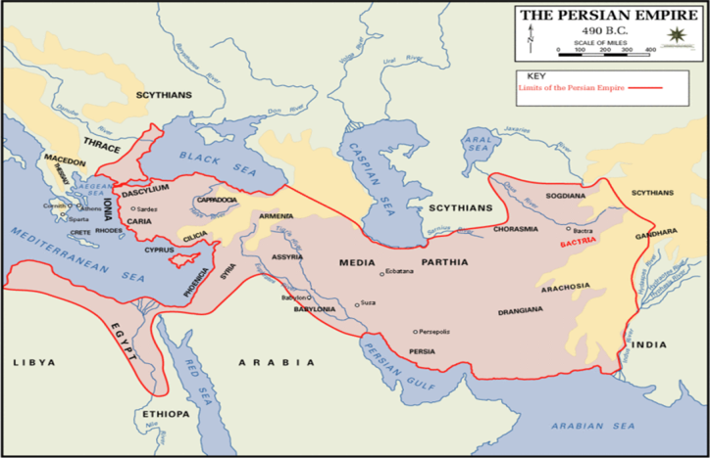
____________________
- Greeks were an ____________________ people who took over the Balkan Peninsula by _______________________
- Early kingdom of _____________________ around 1400s
  - Kingdom in Homer’s epics about the ________________________
- Rapid rise in Greek Civilization from ______________________________
____________________________
- _____________________ concept, rather than a single political unit.
- Trade and economy __________________________
- Alphabet based off of ______________________ alphabet
- Athens and Sparta become the two ____________________________ city-states
________________
- Strong _______________________________ dominating a slave population
__________________
- Strong commercial, ________________________________ (also with slaves)
ATHENS AND SPARTA
- Both city-states cooperated between 500 and 449 to defeat a huge _________________
- After this, ______________ and Greek civilization in general reached its zenith
- In Athens, ______________________ sets the model for democratic negotiation
- Delian League and Peloponnesian League :
___________________________________
- 431-404 BCE
- _______________________________
- Sparta technically wins, but both city-states are so weak that ambitious kings from ________________ soon conquer the cities.
- _________________________________
- Alexander the Great
__________________________________
- Alexander expands Greek influence beyond the peninsula, to…
  - __________________, ____________,__________________ _______________,____________
Short-lived…Alexander dies at 33 after ____________________________________
__________________________________
- ______________________ merge with other Middle Eastern forms during this time period (Hellenism)
  - _____________________________ flourished
  - Important _____________________________ were established like Alexandria, in Egypt

